Outside In: The Power of Putting Customers At The Center of Your Business
“We need our customers more than they need us.”- Harley Manning, Forrester
Take an Outside In approach to customer experience and continue adopting, collecting feedback and revising.
“We are moving from the Information Age to the Age of the Customer and while it may be easy to assume that your business holds control, the truth is the success of your business has never been so dependent on understanding the needs of your customers.” - Kerry Bodine, Forrester
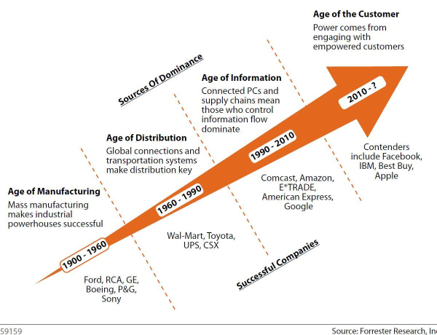

Unified Experience – Omnichannel (milti-channel and multi-devices)
- Place the customer at the center, and design the business around how to optimize the customer experience at every touch point of the business.
- Social media, mobile and the Internet make it easier than ever for customers to leave us for someone "better." It’s vital to include our customers in our processes by collecting meaningful feedback and encouraging them to engage with us seamlessly across all channels.
- Gain insight into the customer experience across every channel versus optimizing within a single channel.
- Customers engage with you anytime (at the gym, on the beach, etc.) across many touch points – Outside In

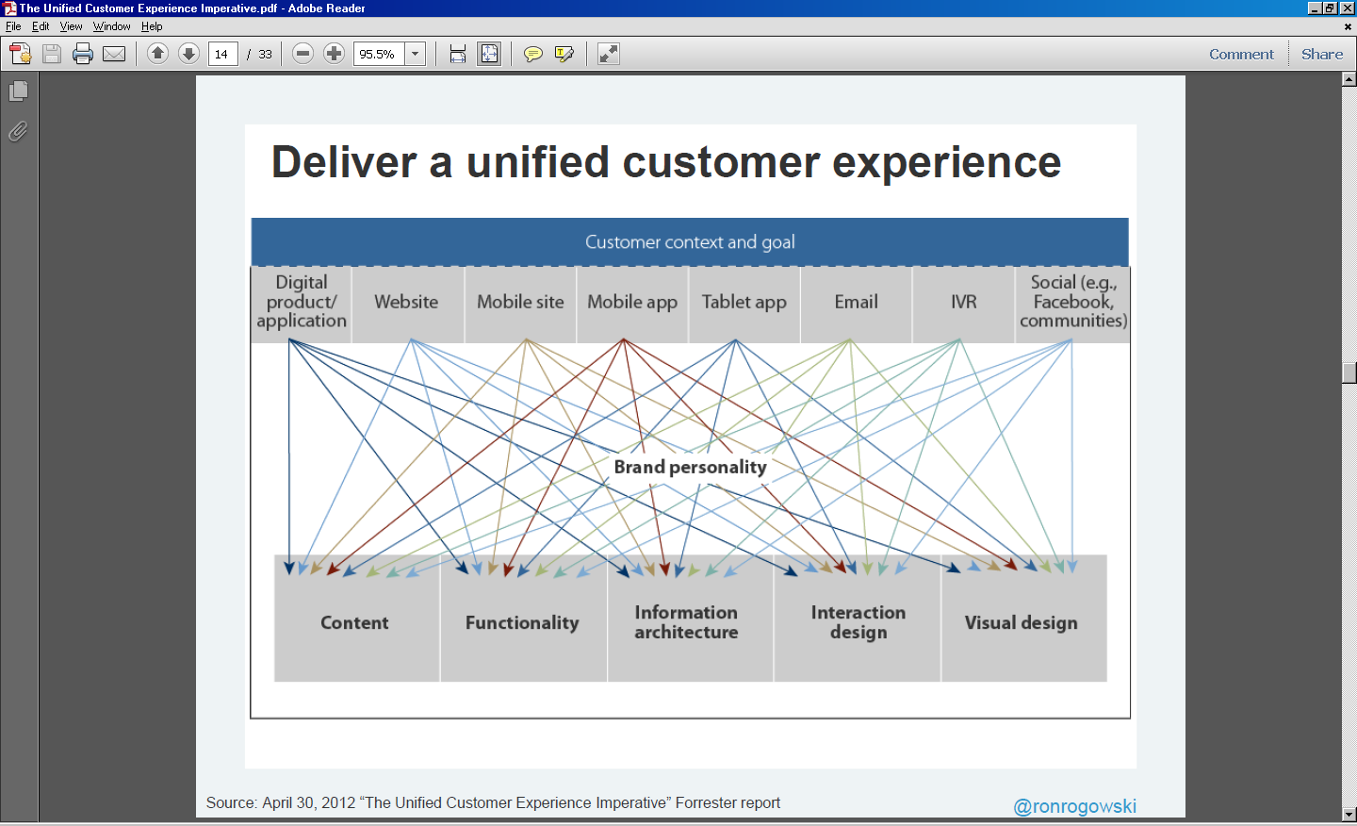
Customer behavior and expectations are changing. They want a unified experience that's customized, aggregated and relevant to them—no matter what channel they're on.
- FedEx is striving to deliver a seamless experience cross-channel. (Brand perception/one message to all channels)
- AT&T takes a mobile first approach, because if they can design an experience for a finger to glass engagement (mobile), everything else is easier.
“Everything should be one swipe away.”- Phil Bienert, AT&T
The customer has become faster and the window of opportunity for capturing them has become smaller - interaction is a challenge never faced before.
- Tablets are outpacing pc’s
- People are replacing Xboxes, TV, etc. with tablets
- On average Millennials change channels between 17-27 times per hour

Customer:
- Digital first (touch finger to device)
- App-centric (more productive, fingertip to piece of glass)
- Merging work & play (texting/tweeting boss at all hours of day is norm)
- Social (talk/interact via mobile tweeting/texting)
- Mobile (anytime anywhere. Inconvenience of picking phone up is absurd, ridiculous) want to do everything from mobile device.

Exceptional Customer Experiences:
- Customized
- Aggregated
- Relevant
- Social

Wants a company that…
- Knows me
- Offer me
- Respect me
- Help me
- Show me
- Connect me

We must create an effortless anytime, anywhere customer experience.
Mobile: A key theme is the fact that customers are ever more mobile and the mobile device has set a new expectation for ease of use and customer experience.
- All new development at AT&T begins with a view for how to deliver the experience on a mobile device first and then the experience is scaled to the other channels (website, tablet, etc.).
- Importance of mobile, vs. laptop/tablet: Customers start in the morning using a tablet to read newspaper/email/news, shift to mobile, then to desktop at work. Then they use the tablet/TV/laptop at night. (Washington Post)
- Mobile is different: Contextual, task-oriented, services layer, and has potential to change behavior, build and increase brand loyalty.
- Consumption of data on mobile devices will take over desktop/laptop internet usage by 2014/2015.
Personalized Experience:
Ron Rogowski, Forrester Research (The Future of Personalization Is…Context!) noted that personalization is understanding what someone needs and presenting it to them in a non-creepy way. Basically, you want to know everything you need to know about your customers, but not necessarily let them know that. Key tactics:
- “Right-sizing” content
- Make content geo-specific to a user’s location and immediate needs
- Provide relevant content/offers in real-time
Customers want personalized content, but need trust. Citi’s strategy leverages big data to gather a combination of credit card spend information, smart phone location and activity information to initiate 1-to-1 localized marketing via mobile for customers who opt-in. The marketing goes beyond personalization (what you know about the person) to contextualization (adds current behavior to past history), which means highly relevant 1-to-1 marketing in real-time. It helps to indentify relevant unique customers and provide valuable unique offers at the most optimal time.

Know what customers are doing in their lives:
- Life events (getting married, divorced, have baby, new job, high school/college
- Infrequently occurring (change of job type, change of residence, starting new business
- Transitional and daily activity
- Changes in spend
  - Auto repairs
  - Job changes
  - Move/House change

Take data and combine with public data (Acxiom) to run sophisticated data models.

Best solution is mobile offers (over email) so consumers get geographically/contextually relevant – right place right time. People downloading applications want them. You can deliver beyond push/pull offers. (i.e. value add – coupons/rebates/etc.)

Social Media: Use Facebook/Twitter to help in the customer experience/response – be engaged and helpful to vastly improve customer experience.

Path to Contextualization Chart
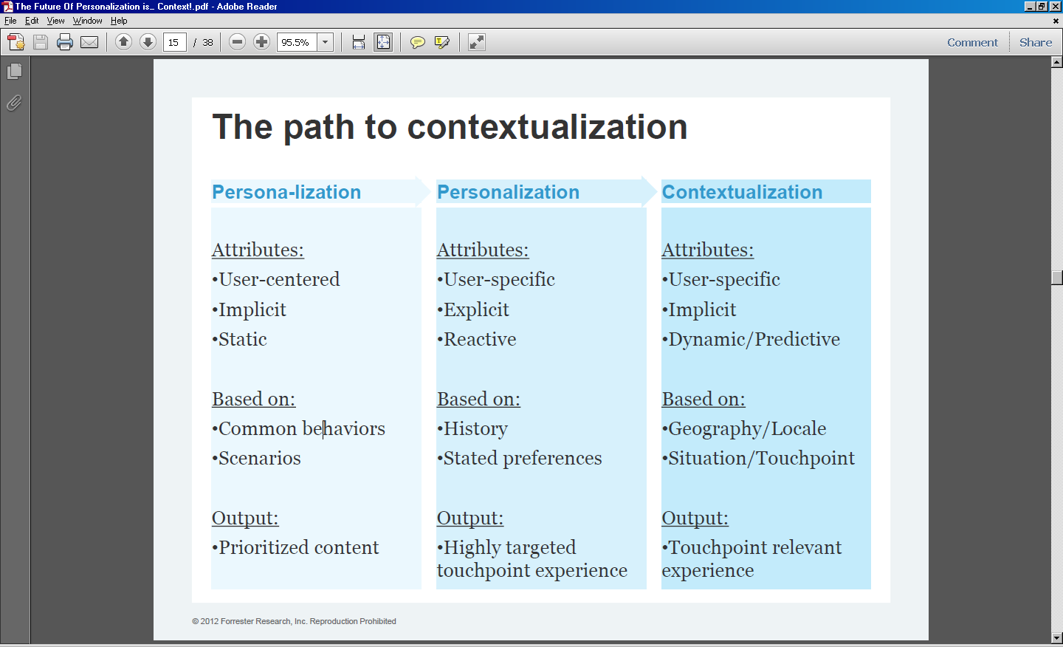

Customer Journey and Social Media:

Conduct journey mapping of personas per channel. A journey map cannot be generic and needs to be relevant to each persona. Social media has transformed customer expectations at every step of the customer journey. Idea is to ensure the customer is on the most direct path to their goal.

How can we start to orchestrate social and traditional touch points?

- Work with cross-functional team in the company – engage front line and back office roles in the customer journey mapping and analysis.
- Understand customers social technographics – profile of customer (what social media do they use in daily lives. Soc Tech gives insight into customers social behaviors.)
- Gather qualitative insights into target customers’ behavior.
- Build personas to describe behavioral segments – critical mass personas encapsulate qualitative insights in formats that support decision making.
- Start by mapping your primary persona’s journey – continual loop map (post its) draw journey map for each persona especially KEY persona – identify where engaging.
- Identify points in the journey to improve with social media.
- Set objectives at the outset and don’t lose sight of them – know what is you want to focus on.
- Develop metrics to measure the impact of social activities. i.e. determine goals for social customer service such as deflecting calls to call center.

Example of Journey Map:

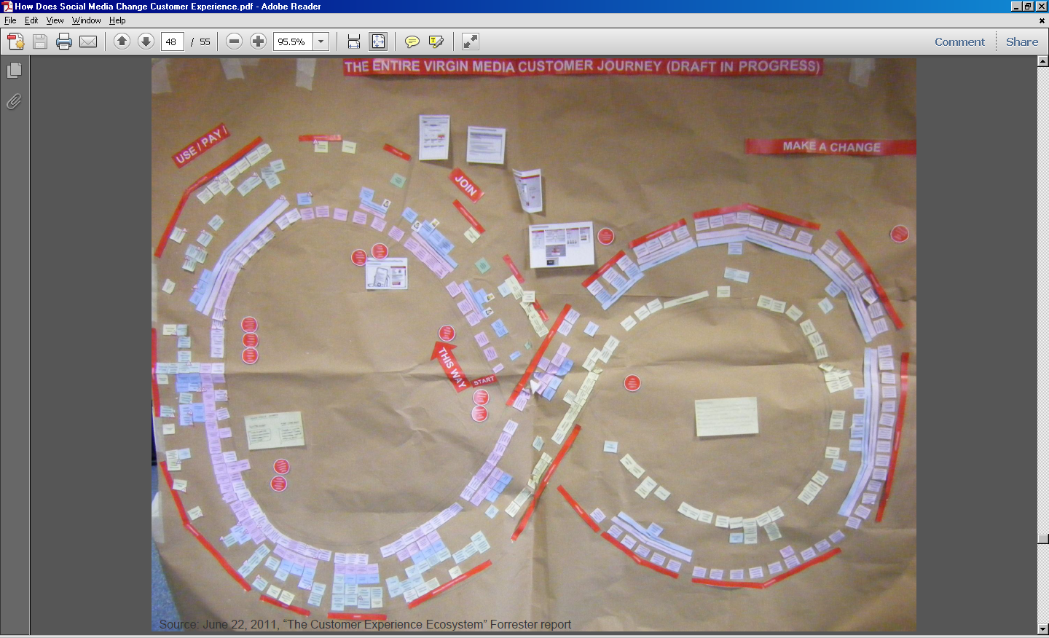
Customer Experience Delivers ROI
If you design excellent customer experience the profits will come. Organizations in Forrester's CXI Leaders grew 22.5% compared to the S&P 500 at negative 1.3% last year. Customer experience is profitable, but only if it is treated as discipline.
- Analysis conducted by Watermark Consulting revealed that Cx leaders wildly outperform laggards.
- Fidelity found that customers with a good experience invested 4.5 times more than those with poor experiences.
- Sprint saves $1.7 Billion a year from decreasing the volume of calls coming into their call center owing to improved experiences.
- Unfortunately, 95% of companies say they are customer focused, but only 8% of customers feel they deliver a superior customer experience.
Customer Experience is a Discipline
"Customer experience is everyone's responsibility and no one's job.”
Results need to be measured and tracked and the end goal shouldn’t be a successful one-off initiative, but a culture that is transformed with a customer-centric perspective.
Listen to customers: collect feedback and data from everywhere and combine it.
- Fidelity learned that people who have good experiences with them invest 4.5x more.
- The President of Office Depot, Kevin Peters, increased North American sales 40% because he stopped focusing on things customers didn't care about and started focusing on what they did. (Tactic: going undercover to experience what his customers were experiencing.)
Trust: build a company culture where employees are empowered – trust and train them by providing the right tools that allow them to overcome unfriendly and broken processes to fully understand customer needs. Culture is key to success. Reward employees for doing the right things and understanding the customer experience.
- Barclays employees start their day by listening to a real customer call.
- Lego includes links in their monthly internal newsletters to snippets of recorded customer calls so non-frontline employees can understand the customer.
The paradox of the empowered customer: It's never been easier to reach customers, but it's also never been harder to engage them. Customer experience is a journey that never ends. Start small, collect feedback, see what it tells you and make changes. Get everyone involved, even departments who are not customer facing. Customer experience is about acquiring new customers, retaining current customers, and building loyalty and fanatics within your customer base. The biggest customer in terms of dollars spent each year, are not necessarily the best customers in terms of influence. Spend time focusing on the design of the customer journey and finding ways to improve the cross-channel experience.
Governance from Top-down: How do you coach the organization?
Kerry Bodine, Forrester, shared a case study from John Deere Financial where they created a change agent program. This group was created to drive customer experience adoption through the enterprise.
- Change agents are trained on customer experience and the customer, then expected to take that back to their departments and help affect change. It helps the culture as well as adherence to governance policies because the entire organization has a better understanding of the customer.
- Make sure employees know why they come to work. Customers do business with organizations they can identify with the mission, vision and purpose. So as you weave your way to customer experience maturity, revisit your mission (your WHAT), vision (your WHERE) and purpose (your WHY).
- Improving customer experience is driven by employees with a passion to serve (and believe in what they are doing). You have to hire the right people, people you trust, and keep them. Invest the time to train and empower frontline employees. Rebuild their trust by demonstrating success from customer experience investments.
A customer-centric culture is a system of shared values and behaviors that focus employee activity on improving the customer experience. Managers can use three tools to create a culture that's customer-centric: hiring, socialization, and rewards. - Paul Hagen, Forrester Research

